Sbormistr (Broken Voices) Wins Best Film at the 16th Annual Czech Film Critics Awards

Czech Film Critics Association Press Release – 7 February 2026

Sbormistr (Broken Voices) won Best Film at the 16th Czech Film Critics Awards for producers Jiří Konečný and Ivan Ostrochovský. Three films – Sbormistr, Otec (The Father) and Letní škola, 2001 (Summer School, 2001) – won two awards each. A total of six films and one miniseries received awards at the ceremony, hosted by satirist Jan Špaček at Prague’s ARCHA+ Theater and broadcast on Czech Television (ČT).

Sbormistr, a drama about sexual abuse and manipulation in a girls’ choir, also earned Best Actress award for Kateřina Falbrová for her disarming performance. Otec (Father), an emotionally charged drama about a father coping with tragically loosing his child, scooped Best Director for Tereza Nvotová and Best Actor for Milan Ondrík.

Letní škola, 2001 (Summer School, 2001) – the first feature film from a Czech-Vietnamese director about the Vietnamese community in the Czech Republic – won the innogy Award for Best Newcomer for Dužan Duong, and Best Screenwriter for Duong, Jan Smutný, and Lukáš Kokeš

Nahoře nebe, v dolině já (Promise, I’ll Be Fine), a sensitive coming-of-age drama set in a poor Slovak region, won the Audiovisual Achievement Award for cinematographer Tomáš Kotas.
Best Documentary went to director Tomáš Hlaváček for Dům bez východu (The Impossibility), a chilling expose of modern-day slum lords.

The OFFSCREEN award for non-theatrical releases was given to screenwriters Miro Šifra & Kristina Májová and director Tereza Kopáčová for streaming service Oneplay’s true crime series Studna (The Well). Best Short Film went to director Anastasia Falileieva for the animated I Died in Irpin, about the first days of the Russian invasion of Ukraine.

The Czech Film Critics’ Awards is organized by the Czech Film Critics' Association with the support of its main partners, innogy, Czech Television, the Czech Audiovisual Fund, and the Czech Ministry of Culture. Other partners include ARCHA+, Champagneria, and mowshe.

Individual critics’ selections are available at filmovakritika.cz
This year’s nominated films as well as previous nominations are available for viewing at kviff.tv.

CZECH FILM CRITICS AWARDS 2025 RESULTS
BEST FILM: Sbormistr (Eng. Title: Broken Voices) – Jiří Konečný, Ivan Ostrochovský, Producers
BEST DOCUMENTARY: Dům bez východu (Eng. Title: The Impossibility) – Tomáš Hlaváček, Director
BEST DIRECTION: Tereza Nvotová – Otec (Eng. Title: Father)
BEST SCREENPLAY: Dužan Duong, Jan Smutný, Lukáš Kokeš – Letní škola, 2001 (Eng. Title: Summer School, 2001)
BEST ACTOR: Milan Ondrík – Otec (Eng. Title: Father)
BEST ACTRESS: Kateřina Falbrová – Sbormistr (Eng. Title: Broken Voices)
AUDIOVISUAL ACHIEVEMENT: Tomáš Kotas (cinematography) – Nahoře nebe, v dolině já, kamera (Eng. Title: Promise, I’ll Be Fine)
INNOGY AWARD FOR NEWCOMER OF THE YEAR: Dužan Duong, Director – Letní škola, 2001 (Eng. Title: Summer School, 2001)
OFFSCREEN AWARD: Studna (Eng. Title: The Well) – Tereza Kopáčová, Miro Šifra, Kristina Májová, Director-Screenwriters
BEST SHORT FILM: I Died in Irpin – Anastasia Falileieva, Director

Principal Partners




Principal media partner
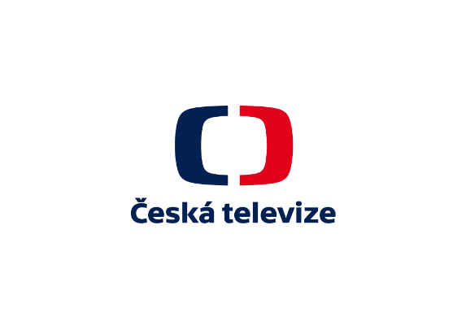
Partners



